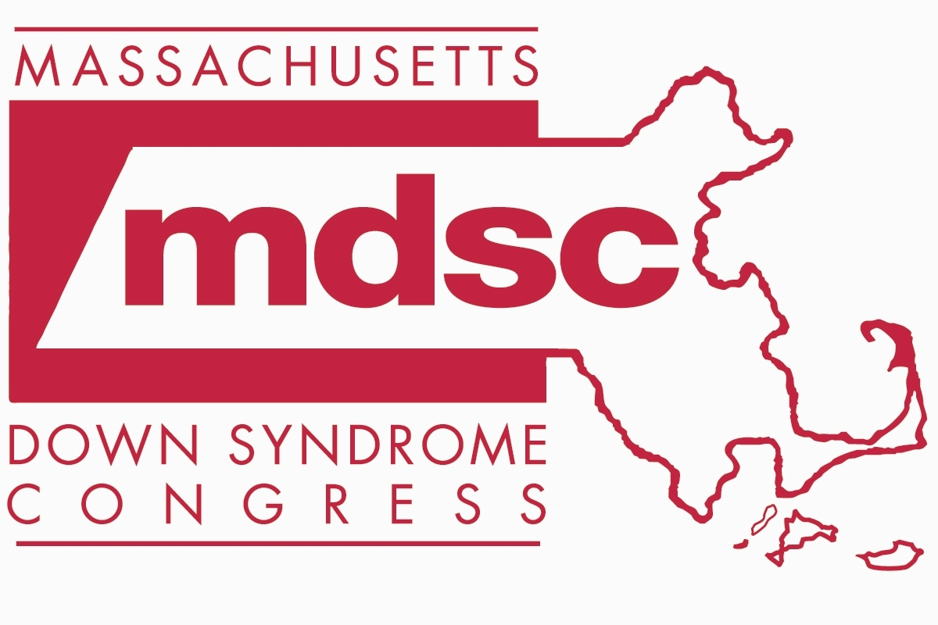 FAX REFERRAL AUTHORIZATION

Massachusetts Down Syndrome Congress (MDSC)
20 Burlington Mall Road, Suite 261
Burlington, MA 01803
(800) 664-6372
FAX: (781) 221-0011

Please print

Child’s Name: ______________________________________ Date of Birth: ____________________ Sex: M / F

Mother’s Name: __________________________________________

Mother’s Email: ___________________________________________

Father’s Name: ____________________________________________

Father’s Email: ____________________________________________

Primary Address: ________________________________ City/State: ___________________________

Zip: _____________ Cell Phone (Mother/Father): __________________________________________

Preferred Language: ____________________________________________________________________________

Person Making Referral: ________________________________ Position/Title: _____________________________

Due to privacy concerns, the hospital cannot share your information with MDSC without your permission. If you would like to connect with us, please complete the following information:

I grant permission to ___________________________ Hospital to release my name, address, phone number and baby’s name and date of birth to the Massachusetts Down Syndrome Congress (MDSC) so that I may be contacted and authorize such contact by the MDSC.

I hereby release ________________________________ Hospital, MDSC and their employees from any and all liability for any and all such claims or damages which may at any time result on account of compliance with this authorization. I also acknowledge that I am the parent or legal guardian of this baby.

Parent/Guardian Signature: __________________________________ Date: ___________________________

Please indicate your preferences for our connection with you:
□ I would like to be added to the MDSC mailing list and have the welcome package mailed to my home
□ I would like to be added to the MDSC mailing list and have the welcome package delivered to the hospital
□ I would like an MDSC First Call parent to contact me by phone about resources and support
□ I would like an MDSC First Call parent to contact me by email about resources and support

Please FAX this form to MDSC at (781) 221-0011

