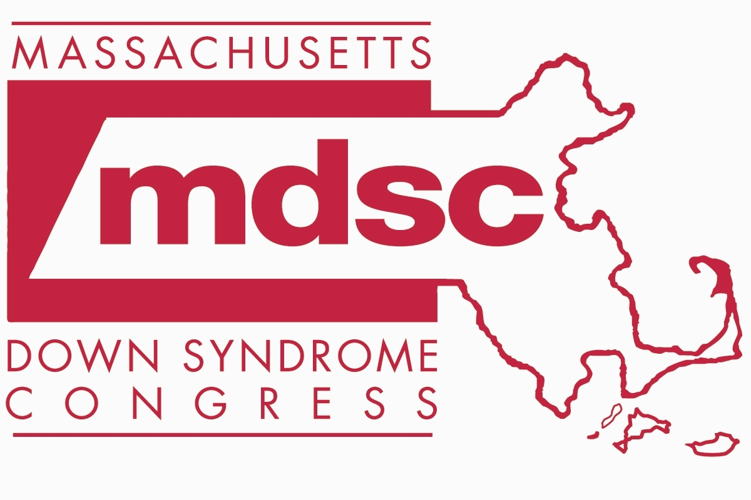

PRENATAL
Request for connection with the Prenatal Parents First Call Program
Massachusetts Down Syndrome Congress (MDSC)

MDSC Prenatal Parents’ First Call program offers expectant families accurate, up-to-date information as well as the opportunity to connect with a parent who also received the diagnosis of Down syndrome prenatally. These parents are available 24/7 to listen, answer questions, and provide accurate information.

Due to privacy concerns, the hospital or medical professional cannot share your information with MDSC without your permission. If you would like to connect with us, please complete the following information:

I grant permission to ___________________________ (Hospital or Medical Professional) to release my name, email and/or phone number to the Massachusetts Down Syndrome Congress (MDSC) so that I may be contacted and authorize such contact by the MDSC.

Signature: __________________________________ Date: ___________________________

Name (please print): _________________________________________________________________________________

Address (street, city/town, state, zip): Optional

_________________________________________________________________________________

Home phone: ____________________________ Cell phone: _______________________________

E-mail: ___________________________________________________________________________

I hereby release ________________________________ (Hospital or Medical Professional), MDSC and their employees from any and all liability for any and all such claims or damages which may at any time result on account of compliance with this authorization.

I am requesting (please check all that apply):
□ Accurate, up-to-date written information about Down syndrome
□ A phone call within 24 hours from an MDSC Prenatal First Call mom
□ A phone call within 24 hours from an MDSC Prenatal First Call dad
□ A phone call within 24 hours from a Spanish-speaking First Call parent

Please FAX this form to: (781) 221-0011 (MDSC)
MDSC, 20 Burlington Mall Rd, Burlington, MA 01803 Phone: (781) 221-0024
www.mdsc.org mdsc@mdsc.org

